

Updating a Test Company
In a Navision Database

February 1, 2006

Updating a Test Company in a Navision Database
This is a step-by-step guide to updating a test company within the Navision Database. Test companies are useful as a training resource and for testing Navision functionality without fear of editing real data. Test companies are created using current data from the main company within the database. It is recommended to update the Test Company data periodically because transactions are not duplicated across companies.
Updating a Test Company
Before starting, ensure all other users are logged out of Navision during this procedure. This is to guarantee that no data is lost during the test company creation.
To view the users that are logged in to Navision, click on File > Database > Information. Click on the Sessions tab. Click on the drop-down arrow in the Current Sessions field. This will open a window displaying everyone who is logged in.
File > Database > Information

Database Information – Sessions tab

Database Sessions
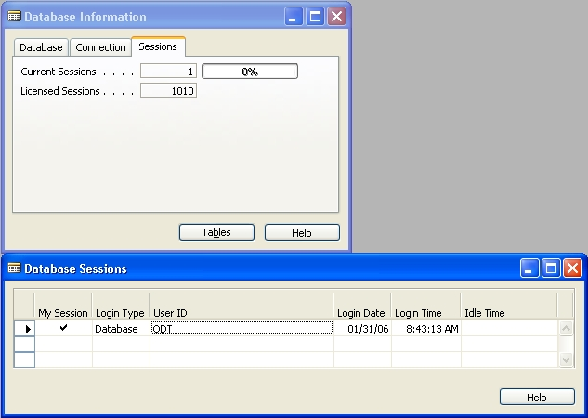
Also, the user that is creating the test company must be a SUPERUSER. Only a SUPERUSER has the permissions to complete all steps.
Step 1: Make backup of entire database and all companies.
Tools > Backup

Backup
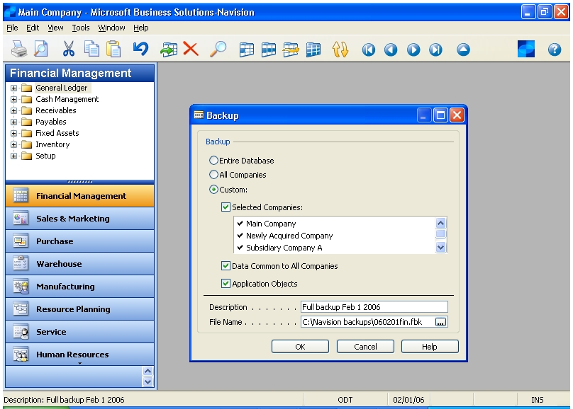
Set the following parameters:
- Entire Database
- Selected Companies
  - Check ALL companies listed
- Data Common to All Companies
- Application Objects
Description: Give a relevant description and it is recommended that the date be included in this description.
File Name: Browse to the location where your backups are stored and give it a unique file name.
Click OK.
A progress window will appear.
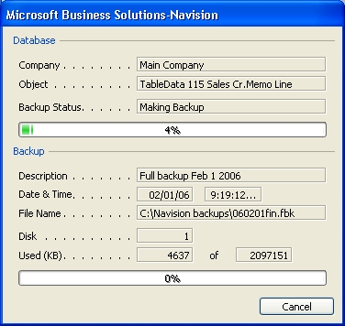
After the backup runs successfully a confirmation message will appear.

Click OK.
Step 2: Open and Delete Old Test Company
Because Navision does not allow two companies to have the same name, the old Test Company must be deleted before renaming the Main Company to Test Company.
Make note of the EXACT Test Company name. An excellent way to do this, is to copy the name while in the Open Company window, and pasting it into Notepad. If the name is changed in any way, users, including the SUPERUSER, may be locked of this company. User permissions are not updated for changes in company names.
File > Company > Open

Open Company
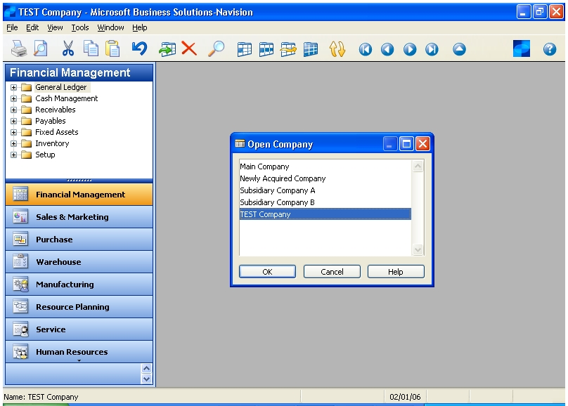
Confirm that the Company name in the top left Header is the correct company.
Next, delete this TEST Company. Go to File > Company > Delete.

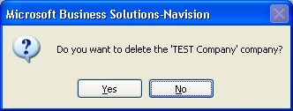
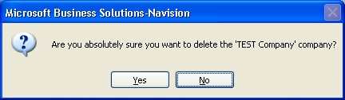

Two confirmation messages will appear, click Yes on both to delete the Test Company.

Step 3: Rename Company to TEST Company
Open the company for which you wish to create a Test Company.
File > Company > Open

Open Company
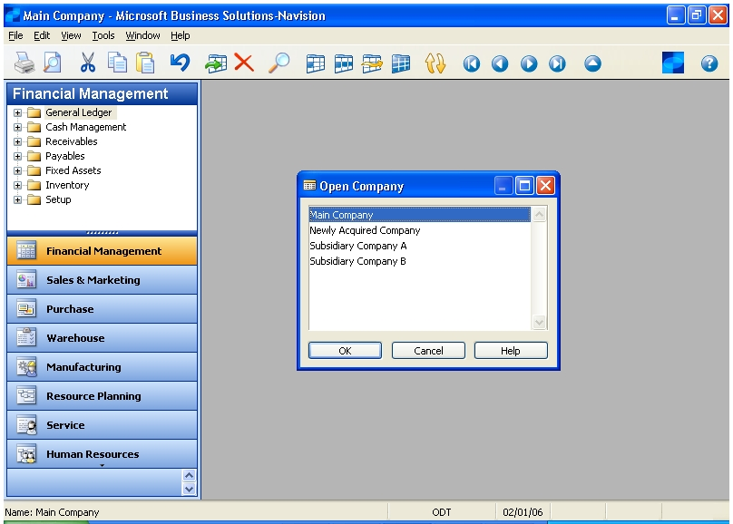
Confirm that the Company name in the top left Header is the correct company.
Next, rename this company to TEST Company (or any other name you wish). Go to File > Company > Rename.

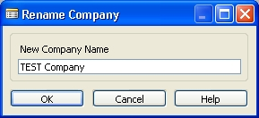
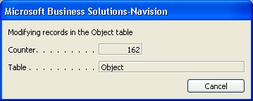

Type “TEST Company” in the New Company Name field. Click OK. A progress window will appear as the tables are being updated. When this is complete, confirm that the Company name has been changed to the new TEST company name.
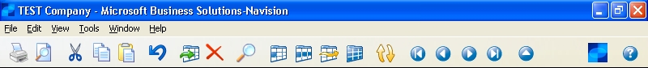

Step 4: Restore Main Company
As Navision will restore the data based on company names; the restore process will automatically create the company that was renamed to TEST Company. Navision does not allow two companies to have the same name in a database. If the main company had not been renamed to Test Company, then an error would have prevented this step. Both companies will contain the same data.
Bo to Tools > Restore.
Browse to the backup you just created.
Click on Custom Backup and select only the company that you just renamed.
Click OK.
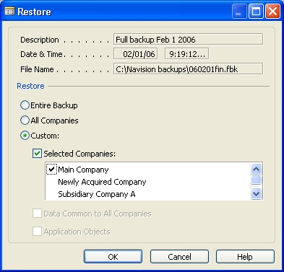

There will now be a Test Company, Main Company, and any other companies setup in Navision. The Test Company will have the same data as the Main Company and will be ready for use.


