

Federal Tax Updates

July 11, 2006
V3.6 – V4.0 Edition 01
Table of Contents
What’s New 1
Importing Payroll Control Data 2
Manually Updating Payroll Control Data 4
Bracket Details 4
Bracket Code – FED LOW RATE 4
Bracket Code – FED TAX 5
NEW Bracket Code – MAX EMPLOYMENT CRED 6
Method Steps 7
Changing the Basic Personal Exemption 8

What’s New
Changes to the Federal Basic Personal Exemption (Federal TD1) and base tax rate come in to effect July 1st, 2006.
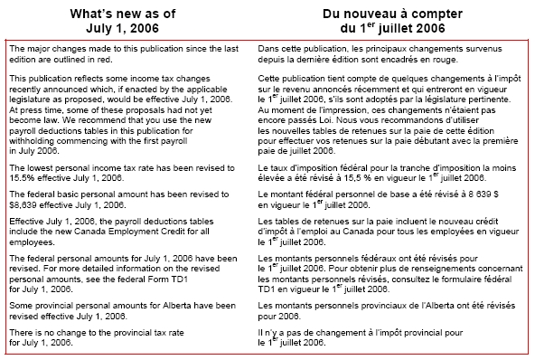
Two updates are required prior to running your first payroll of July. A few steps are required to complete this update, bracket details need to be updated, method steps need to be updated, and the employee TD1 values need to be updated. The brackets and method steps can be changed either manually or through an import file. But the import file may cause problems if your payroll setup has been altered from the standard. Either method will only take a few minutes to perform. And the employee basic personal exemption is changed with a Mass Update.
The first section outlines the import process, the second section outlines the manual process, and the last section outlines updating employee TD1 values.
If you have any questions, please contact Support at Open Door Technology via HelpDesk or support@opendoor.ca.

Importing Payroll Control Data
Save the “360_400CANTaxDat1.txt” File to your local directory.
From the Payroll Menu > Periodic Activities > Import Pay Control Data
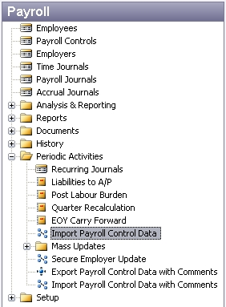
The following screen will open:
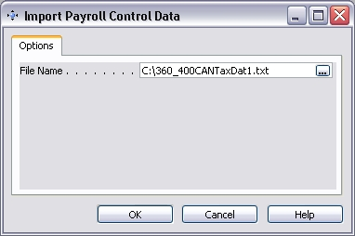
Using the browser , locate the saved text file and click OK. The import process will run and the following screen will open:
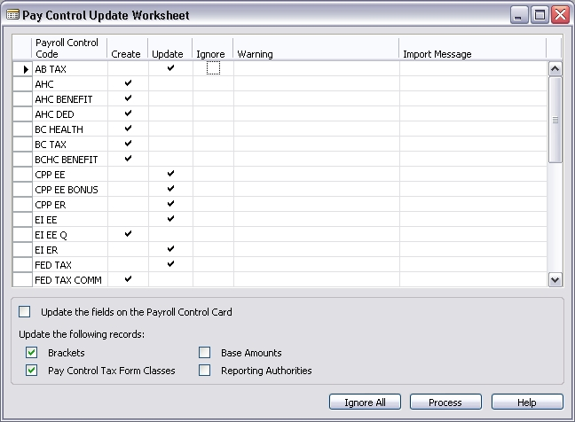
Change these Create flags to Ignore for the Pay Controls that you do not want created!
Be sure to change the Create flag to Ignore for those pay controls that you do not want in your payroll setup. Also, leave the Update the fields on the Payroll Control Card, Base Amounts, and Reporting Authorities fields unchecked.
Click the Process button.
Note that the Import Message should now read either “Record Updated” or “Record Ignored”.
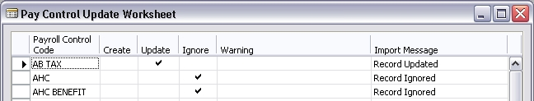
Manually Updating Payroll Control Data
Bracket Details
Payroll > Setup > Calculation > Brackets
Bracket Code – FED LOW RATE
Changes to the ‘FED LOW RATE’ Bracket Code will affect the following Payroll Controls:
- FED TAX
- FED TAX OUT
- FED TAX Q
If the Bracket Code that you use is NOT the same as that show below, or if you have modified the Bracket, you will have to manually make the following changes:
- Bracket Type Code = TAX CREDIT
- Effective Date = 07/01/06
- Description = Federal – Total Credits Claimed x Bracket %
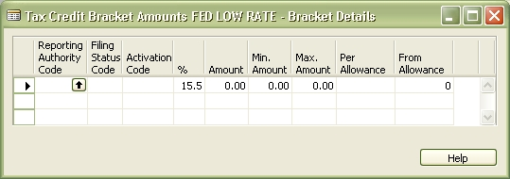

Bracket Code – FED TAX
Changes to the ‘FED TAX’ Bracket Code will affect the following Payroll Controls:
- FED TAX
- FED TAX OUT
- FED TAX Q
If the Bracket Code that you use is NOT the same as that show below, or if you have modified the Bracket, you will have to manually make the following changes:
- Bracket Type Code = WITHHOLDING
- Effective Date = 07/01/06
- Description = Federal – Total Credits Claimed x Bracket %
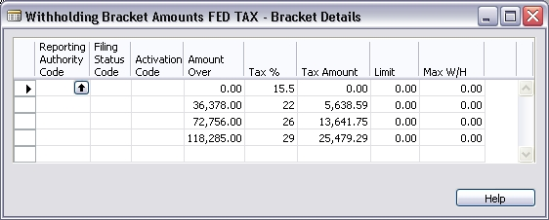

NEW Bracket Code – MAX EMPLOYMENT CRED
Changes to the ‘MAX EMPLOYMENT CRED’ Bracket Code will affect the following Payroll Controls:
- FED TAX
- FED TAX OUT
- FED TAX Q
This Bracket Code is new and will require setup through Payroll > Setup > Calculation > Brackets. Click F3 to insert new line.
- Bracket Type Code = LIMIT + TAX %
- Effective Date = 07/01/06
- Description = Low Rate X Max Employ. Credit
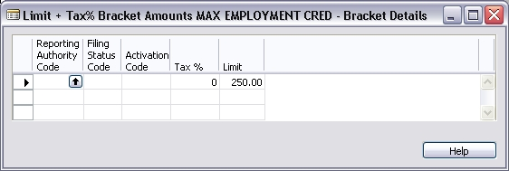
The maximum of $250.00 is only applicable for the remainder of 2006. We will also add the 2007 maximum of $500.00, which will be used after December 31, 2006.
- Bracket Type Code = LIMIT + TAX %
- Effective Date = 01/01/07
- Description = Low Rate X Max Employ. Credit
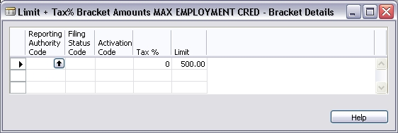
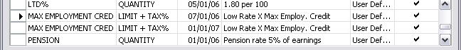
Method Steps
A new arrangement of method steps is required to incorporate the new Employment Tax Credit into the federal tax calculation.
The calculation changes will affect the following Payroll Controls:
- FED TAX
- FED TAX OUT
- FED TAX Q
Go to Payroll > Payroll Controls > FED TAX payroll control card. Click on the Calculation button > Calc Method. Copy the most recent Calc Method line and specify the new effective date of 07/01/06 when prompted. View the steps on the newly created 07/01/06 Payroll Calc Method and alter them to the following arrangement:
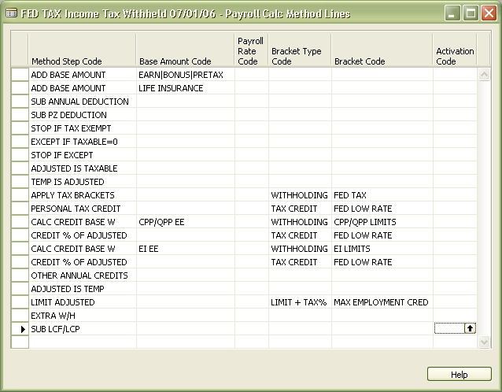
The second ‘ADD BASE AMOUNT’ line may not be required if there are no taxable benefits.
These changes must also be made on the FED TAX OUT and the FED TAX Q payroll controls, if they are being used in your payroll system.
Changing the Basic Personal Exemption
This process can be run in a test mode prior to applying the update. The process will insert a new Tax Authority record on the Employee Card > Tax Authorities – it does not replace the existing record. If an employee has additional credits, the process will increase / reduce the existing TD1 value by the amount of change to the basic exemption.
From the Payroll Menu > Periodic Activities > Mass Updates
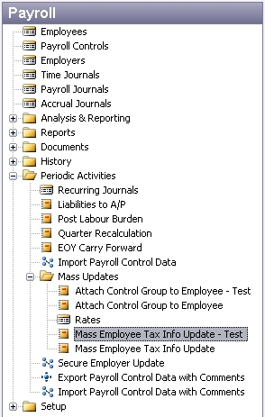
Select Mass Employee Tax Info Update – Test.
The following screen will open.
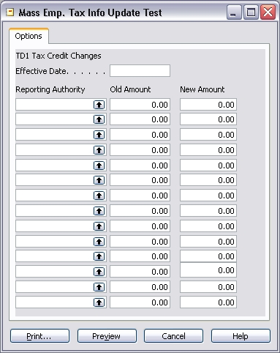
Use an effective date of July 1st, 2006.
Using the look up on the Reporting Authority field, select Federal.
In the Old Amount field, enter 9039.00.
In the New Amount field, enter 8639.00.
Your screen will look like this:
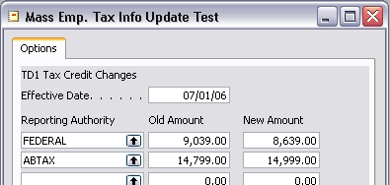

Print or Preview the report. The report will give you before and after values for all employees.
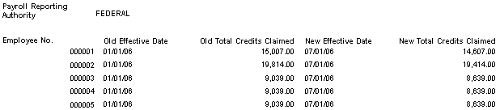
From the Mass Updates menu, now select Mass Employee Tax Info Update. Complete the process, now in update mode.
Note: Choosing Print or Preview will apply the update.
On the Employee Card, the new TD1 values will now be in place.


