Employee

FactBoxes
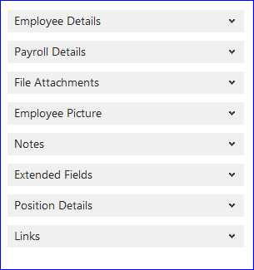

File Attachments
Located throughout Payroll and HR; allows you to attach any type of file. Drag and Drop.
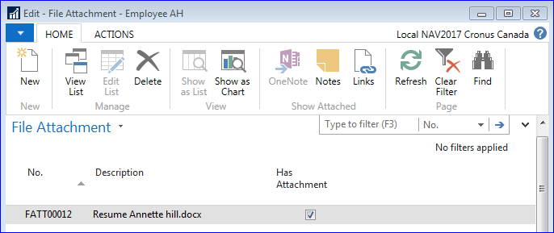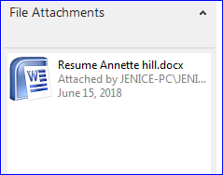

Employee Payroll Controls
Employee > Payroll Controls > Description field
The Description is used when creating reports to be sent to vendors.
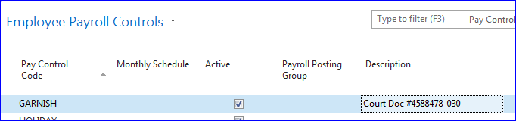

Employee Relatives
If the Employee’s Relative is also an Employee; the 2 records can now be linked.
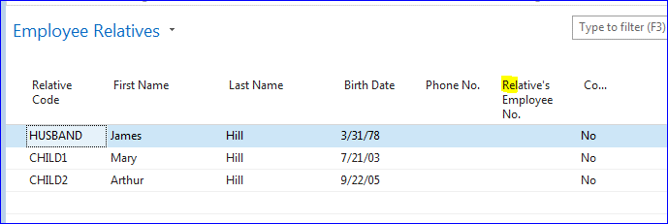

Employee Extended Fields
Extended Fields allow you to setup an unlimited number of user defined fields to track information.
And attach to an Employee record.
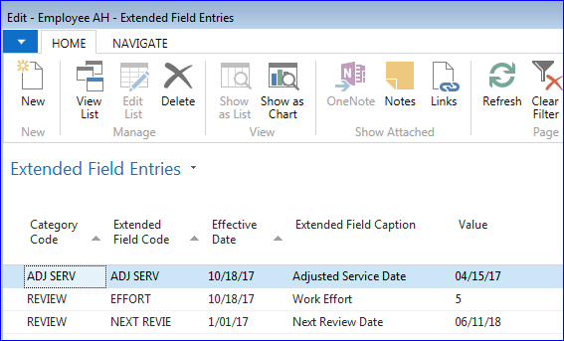
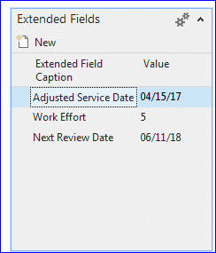

Employee Position
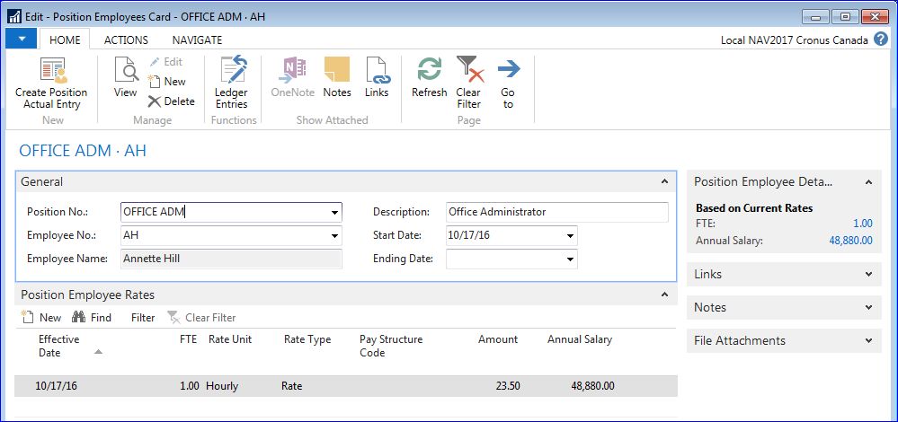

Payroll Controls
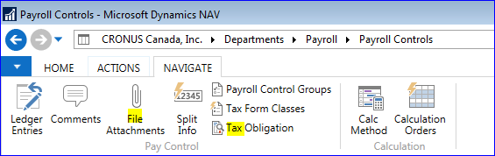

Tax Obligation
The Pay Control Tax Obligation settings allow a user to determine how a pay control affects the
“Taxable Gross Income” calculation.
These setup and calculation options can be used in place of the older “Base Amount” concept to
insure there are less user defined fields which can be affected by automated tax update imports.
The base amount concept is still functional as a more flexible option, when needed, by more
complex installations.
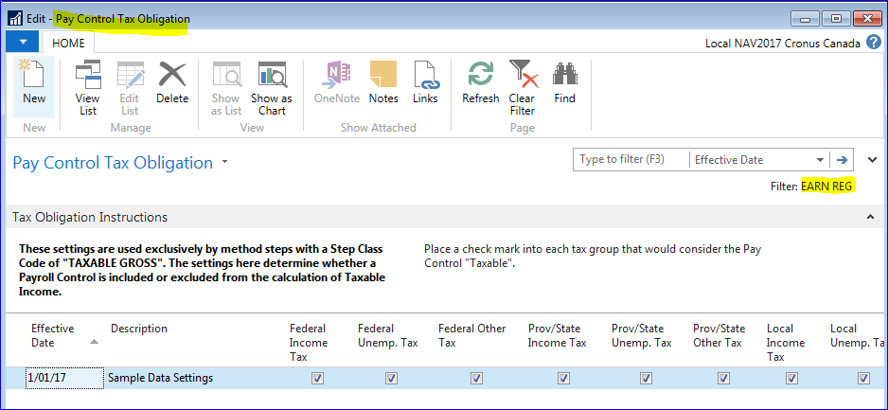

File Attachments
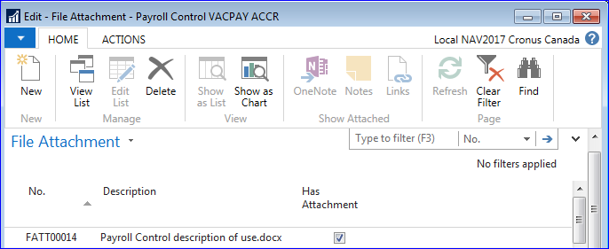

New Method Steps
New Method Steps have been added,
Providing greater options when creating Calc Methods.

ROE Reporting
Service Canada now requires a further breakdown on the Vacation Pay and Other Money Types.
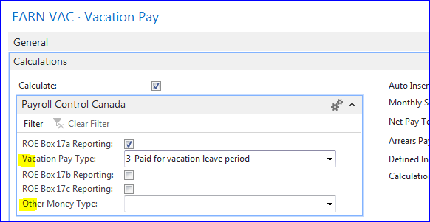

Export Tax Data and Setup
Along with the Import Payroll Control Data, the Export is now available from the Main Menu.

Employer

New fields
T4/T4A Contact Email
Employer Details > Employee count now displayed by ‘Status’
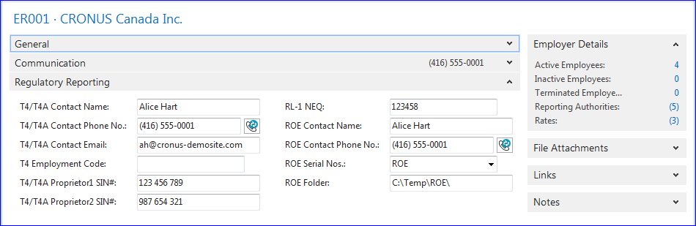

Reports

Liabilities to A/P Detail
This report contains the details as backup that may be provided to AP to accommodate the payments.

Payroll Control Tax Group
By Tax Group, provides the Payroll Controls within each Tax Group and the Tax Obligation

Payroll Control Tax Obligation
By Payroll Control, provides the details of the Tax Obligation selected on the Payroll Control.

T4 Laser/T4 Summary

New fields

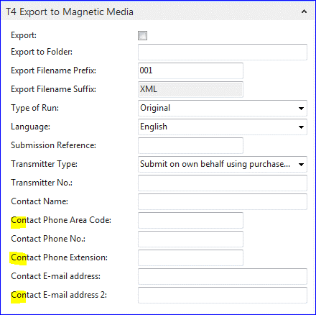

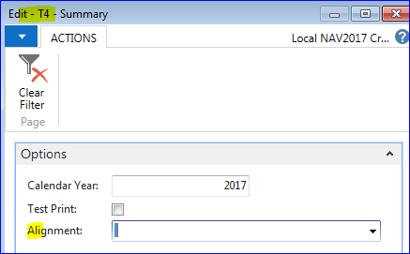

Payroll Setup

Posting Date Source
In this field you are selecting whether the Work Date or System Date (TODAY) should be used as the default value of the Posting Date in the Payroll Journal

Pay Period Source
In this field you are selecting whether the Pay Period End Date or Pay Date is used when determining which Pay Period to use as the default.
If the field is set to End Date the system finds the correct pay period by looking for the Posting Date that falls between the Start Date and the End Date of the pay period. The System looks for the first pay period that matches the criteria and this is the one that is used.
If the field is set to Pay Date the system finds the correct pay period by looking for the Posting Date that falls on or after the Pay Date of the pay period. The System looks for the first pay period that matches the criteria and this is the one that is used.

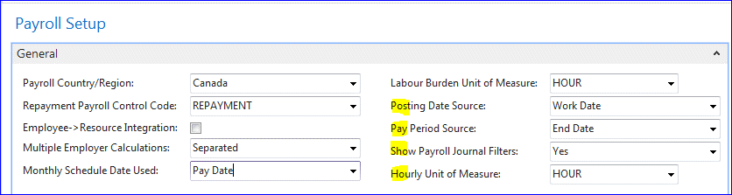

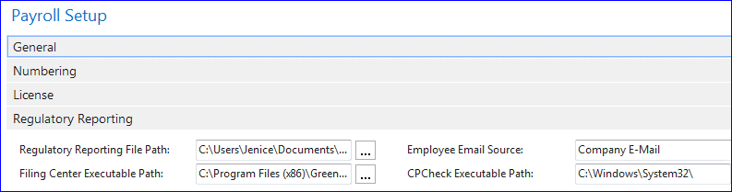

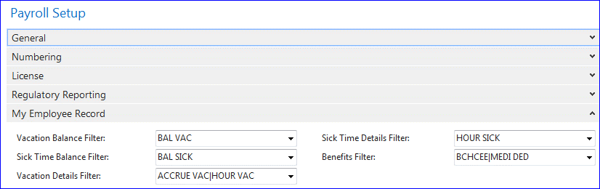

My Employee
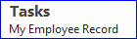
The My Employee Record feature gives each employee access to fields on his/her Employee record (e.g., addresses, contacts).

To access the My Employee Record feature, select Departments > Human Resources > Tasks. Alternatively, if you have the HCM Employee Self Service Profile assigned to your user record (Administration > Application Setup > RoleTailored Client), you can click the My Employee Record link. From the menu, click HR > Tasks.

From your record, you will be able to view, and in some cases edit, several pieces of information, including addresses, contacts, benefit rates, vacation and sick balances, and pay checks.
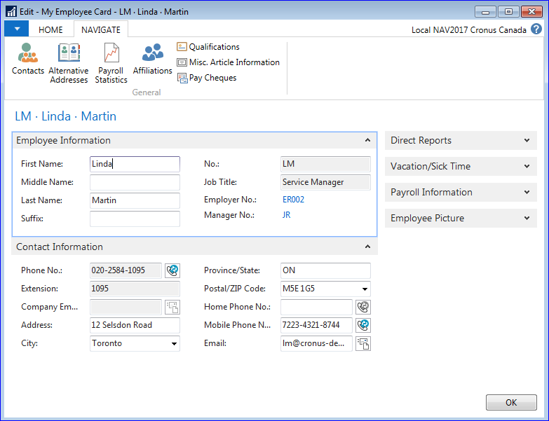

User Setup
Settings for the Allow Calc Trace in the Payroll Journal and Time Sheet Admin.
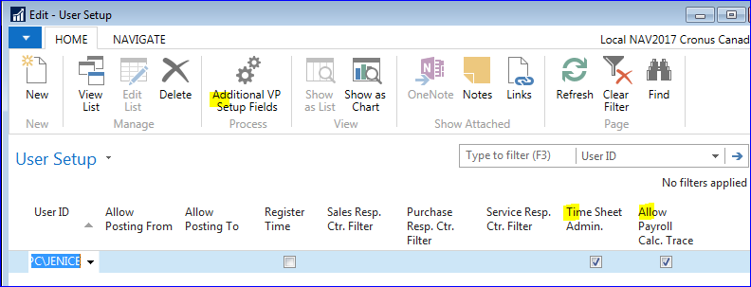
Linking the User to their Employee record.
Defining Time and/or Expense access
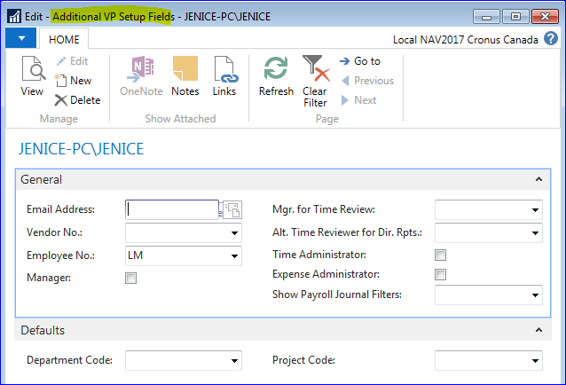

VP (VisionPayroll) Time & Expense
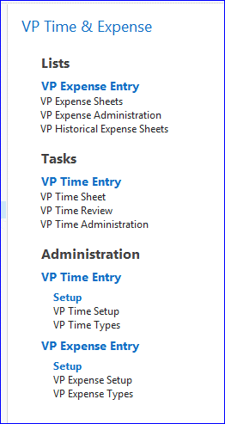

Human Resources

Employee Directory

Reports and Analysis
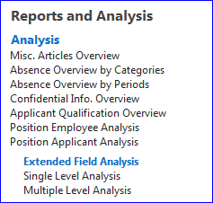

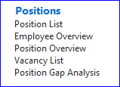

Positions
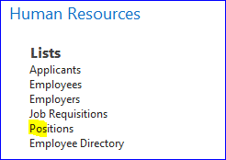

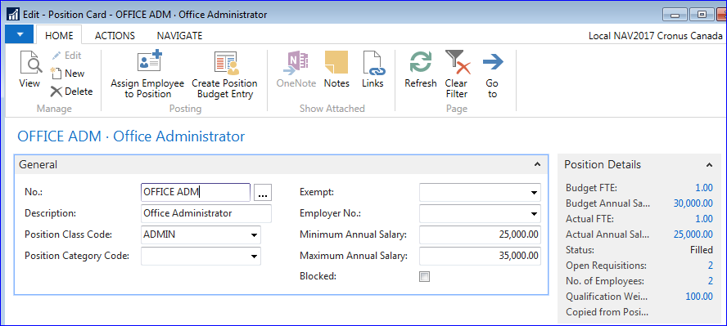
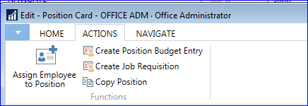
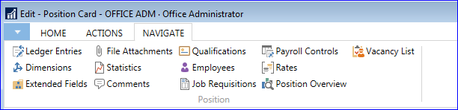

Setup
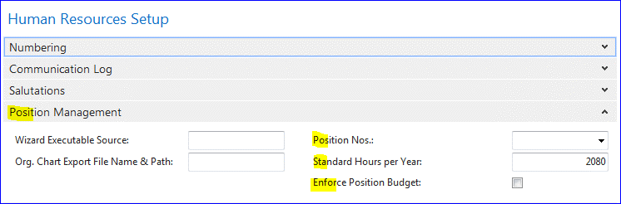
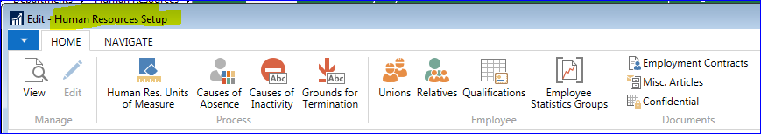
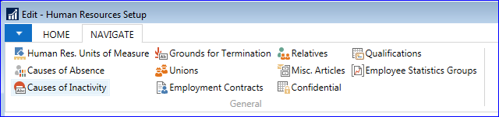

On Line Help
Access to Payroll and HR Information via the Internet
